Nepal College of Information Technology
Assessment
Spring 2012
Program : ELX Time : 3 hrs
Semester : (IV) FM : 100
Subject : Numerical Methods PM : 50
- Candidates are requested to give their answer as far as practicable in their own words.
- The figure in the margin indicates the full marks
- Attempt ALL question

1. | a. | Find the root of the equation 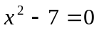 with accuracy 0.0009, using False Position method. | 8
 | b. | Calculate the root of non-linear equation 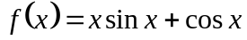 using Newton Raphson method. The absolute error of functional value at your calculated root should be less than 10⁻⁴. | 7
2. | a. | Use appropriate method of interpolation to get 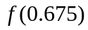 from given table. | 8
  x | 0.125 | 0.25 | 0.375 | 0.5 | 0.625 | 0.75
  F(x) | 0.7916 | 0.7733 | 0.7437 | 0.7041 | 0.6532 | 0.6022
 | b. | Use the suitable method to fit a quadratic curve 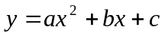for the following data: | 7
  x | -3 | -2 | -1 | 0 | 1 | 2 | 3
  y | 4.63 | 2.11 | 0.67 | 0.09 | 0.63 | 2.15 | 4.56
3. | a. | Evaluate the integral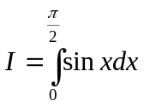, Compare the result in both conditions for Simpson’s 1/3 and Simpson’s 3/8 rule. | 10
 | b. | The following data is the record of distance travelled by a car at various time invervals during its speed.  Find the velocity and acceleration at 5min, 7min and 9min. | 5
  Time intervals ‘t’ min | 5 | 6 | 7 | 8 | 9
  Distance travelled ‘d’ m | 1200 | 1350 | 1600 | 2000 | 2500
4. | a.  b. | Using power method, find the largest eigen value of the following matrix. 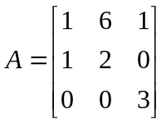  Solve the following linear equation by Gauss Jordan method.  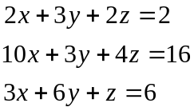 | 8  7
5. | a. | Solve the following differential equation within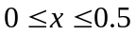 using RK 4th order method. 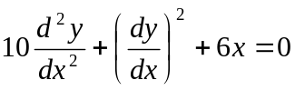, with 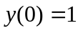and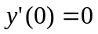. (take h=0.25) | 8
 | b. | Solve the Poission equation 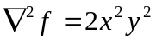, over the square domain of 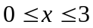 and 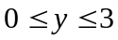 with 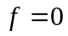 and 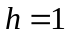 | 7
6. | a. | Solve the differential equation 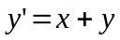 using Heun’s Method within 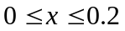with h=0.1 and . | 8
 | b. | Use the suitable method and determine the exponential fit of 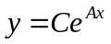for the following data: | 7
  X | 0 | 1 | 2 | 3 | 4
  Y | 1.5 | 2.5 | 3.5 | 5.0 | 7.5
7. |  | Write short notes on (Any Two) (5×2) | 10
 | a. | Errors in Numerical Methods.
 | b. | Pivoting Techniques.
 | c. | Partial Differential Equations.

